Certification Questionnaire for Coast to Coast Journeys

General

Products and Certifications - Done

Payment Types - Done

Workflow - Pending response

What is your workflow for the integration with the ETG API? Please describe each step, from search to cancellation, and include details about the ETG API methods used at each step.

The name for your step | Your step logic (stating the action the user should perform for your system to initiate a call to the ETG endpoint/endpoints) | ETG endpoint/endpoints
User Search |  | /search/serp/hotels/ /search/serp/region/
Hotel List Display | Show hotel cards with ratings, prices, photos | N/A
Hotel Details Page | get rates for specific hotel | /search/hp/
Room Selection | User selects a room rate (book_hash captured) | N/A
Pre-booking Validation | Verify price, availability, cancellation terms | /hotel/prebook/ with book_hash
Guest Information Form | Collect guest details, payment info | N/A
Start Booking | Receive partner_order_id | /hotel/order/booking/form/
Finish Booking |  | /hotel/order/booking/finish/
Poll Status | (every 2.5s, max 60s)Wait for status: "ok" | /hotel/order/booking/finish/status/
Confirmation | Display booking confirmation  Send confirmation email via Brevo
Post-Booking | for voucher/details | /hotel/order/info/

Second update: Thank you for the table provided!
During my recent tests, I observed that the search and booking requests originating from our integration are not being sent with our designated API key, which is key_id: 83.
To allow us to complete our checks and monitor the traffic correctly, could you please configure your system to ensure that all API requests (both for search and booking) made through our integration are sent using key_id: 83?

IPs Whitelist - Pending adjustments
I noticed in your checklist that you're using dynamic IP addresses. Our security systems only work with static IP addresses. Therefore, could I ask you to set up proxying via a static IP address and provide these addresses to us?

InterServer VPS with Nginx reverse proxy - VPS cost: $6/month - Static IP will be provided to ETG for whitelisting - Proxy routes only ETG API calls through static IP

Second update: Thank you, after Static IP will be set, please indicate it here

RPM Limits - Pending response
Please specify the expected RPM limits for the below endpoints depending on the endpoints integrated:

  - /serp/hotels: Expected 50, Maximum 100
  - /serp/region: Expected 30, Maximum 60
  - /serp/geo: Expected 20, Maximum 40
  - /search/hp: Expected 40, Maximum 80
  - /hotel/prebook: Expected 20, Maximum 40

Second update: I see that some of our limits are not met:
Limits on our side:
- The “Search by region” - 10 RPM
- The "Retrieve hotelpage" - 10 RPM
- The "Prebook rate from hotelpage step" - 30 RPM
- The "Create Booking process" - 30 RPM
- The "Start Booking process" - 30 RPM
- The "Check Booking process" - 30 RPM
- The "Cancel booking" - 30 RPM
- The "Retrieve bookings" - 30 RPM

Unfortunately, some of the RPMs you specified don't match ours. Could you please let me know if it's possible to make adjustments to accommodate the limitations mentioned above?

Hotel Static

Hotel static data upload and updates - Pending response
In your checklist you indicated:
- We will update the hotel static data using both the “Retrieve hotel incremental dump” and “Retrieve hotel dump” methods
- We use “Retrieve hotel content” (/hotel/info) to get the static data
Could you please describe in more detail how exactly you plan to use these calls and how often you will use each call?

We use both methods: - Full Dump ( /hotel/info/dump/ ): Weekly updates - Incremental Dump ( /hotel/info/incremental_dump/ ): Daily updates

Yes, we use the Content API to enrich hotel pages with real-time static data including: - Hotel descriptions - Policy information (metapolicy) - Amenities - Star ratings

Second update:The Content API is currently not enabled for your key.
This is because the Content API is not designed for real-time use, so it cannot be used in real time.
The Content API is merely an alternative to dumps, and the Content API should only be used to update your database.
Please indicate whether you want to enable Content API methods, and if so, describe how you will use it.

The number of mapped regions / hotels - Done

Hotel important information - Pending adjustments
It has come to my attention that your website’s hotel pages are not displaying critical policy information for users.

Currently, all relevant hotel policies are provided within the metapolicy_extra_info and metapolicy_struct parameters. It is crucial that all information from these fields is made visible to the user on the hotel page. The absence of this data can lead to significant problems for our customers during check-in. For instance, a user might arrive with a pet, unaware of a "no pets" policy, and subsequently be denied accommodation.

To prevent such negative experiences, I would like to request that you implement the display of all values contained within the metapolicy_extra_info and metapolicy_struct parameters for every hotel. This data can be sourced from our static data dumps.

Important Note: Our static data also contains a parameter named policy_struct. This parameter is deprecated and should be completely ignored.

May I ask you to make some adjustments so that metapolicy_extra_info and metapolicy_struct are displayed on hotel pages?

Yes, we parse and display metapolicy_struct and metapolicy_extra_info

Second update: I’ve checked the information from your website for hotel with hid: 6362880
However I don't see any information from metapolicy_extra_info
Regarding the metapolicy_struct I see that not all policies are showing fully and correct
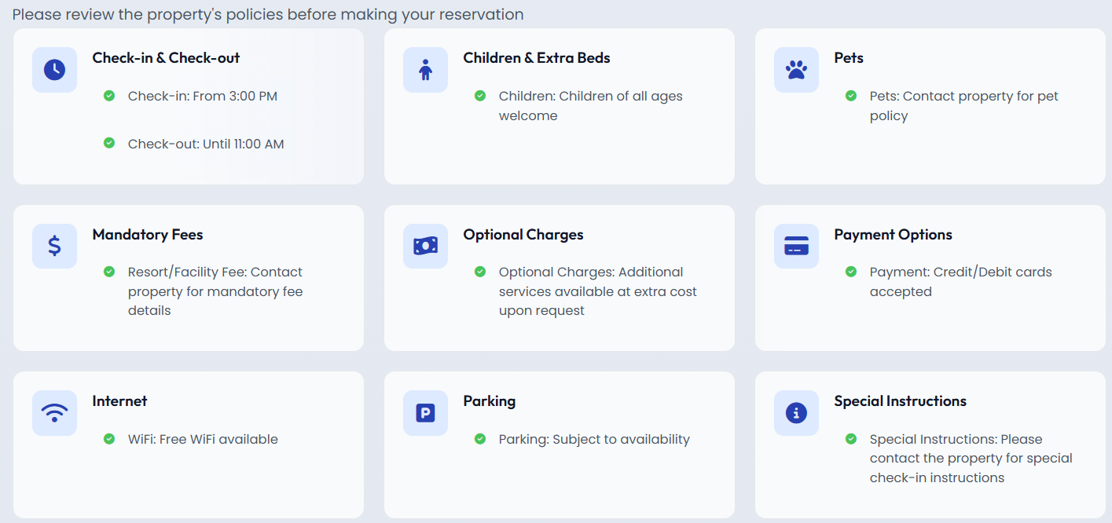
As example in metapolicy_struct.parking the hotel with hid: 6362880 have no any value,but the website shows that it is subject to availability. Also I don't see some parameters as “meal” policy

May I ask you to make some adjustments so that all parameters from metapolicy_extra_info and metapolicy_struct are displayed on hotel pages?

Room Static data - Pending response
Do you plan to show images and amenities of ETG rooms for ETG rates?

If the answer to the previous question is yes, please describe your process for matching rates from the search with room groups from hotel static data. What parameter do you use for matching?

Yes, we display room images and amenities from ETG
We match rates using rg_ext.rg from the rate response to room_groups[].rg_hash in static data
# Match rate's rg_ext.rg with room_groups[].rg_hash
rate_rg = rate.get('rg_ext', {}).get('rg')
for room_group in hotel_static.get('room_groups', []):
if room_group.get('rg_hash') == rate_rg:
matched_room = room_group
break

Second update: In our static data we have a similar rg_ext arrays structure to rg_ext arrays structure in dynamic data, and we don't have “rg_hash” parameter in static data
Could you please describe what is rg_hash in static data?

Search Step

Match_hash usage - Done

Prebook rate from hotelpage step - Pending test environment and response
Second update: To verify this point, I need to conduct a test booking through your website, but it currently operates independently of the API. Could you please configure your website to use our API?

Also could you please indicate how you work with the “price_increase_percent” parameter?

Cache - Done

Children logic - Pending test environment
I see that your website considers adults to be people over 12 years old.
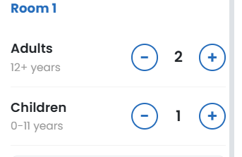
Let's imagine a situation where two people, both 30 years old and their 15-year-old child, want to make a booking. They list all three as adults, but according to the hotel's rules, the 15-year-old is considered a child. In this case, the booking will be incorrect, the child may be denied check-in, and the customer will end up with a negative experience.
Based on this, may I ask you to make adjustments so that it is clearly displayed to the client that an adult is considered a person aged 18 years and above.

Also please add all ages (0-17) in age dropdown menu:
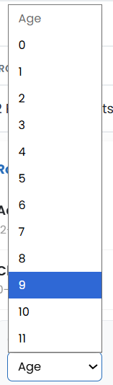

Second update: Thank you very much for your corrections!
To fully close this point, I need to conduct a test booking through your website, but it currently operates independently of the API. Could you please configure your website to use our API?

Multiroom booking - Pending test environment
In your checklist you indicated: “No, we do not work with multiroom-booking”
However I see that your website allows to book multiple rooms.
Also I see that the website itself allows you to select 8 adults.
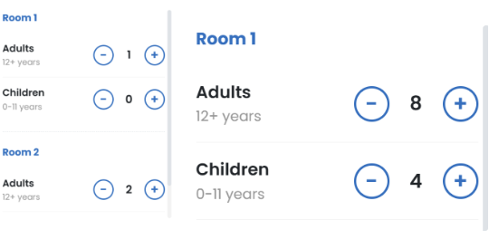
In this case, specifying this number of guests will return an error because:
Maximum number of guests per room (adults + children) - 10
Maximum number of adults per room - 6
Maximum number of children per room - 4
May I ask you to make adjustments so that when searching, you can't specify more than 4 children and more than 6 adults per one room?

Yes, we support multiroom bookings
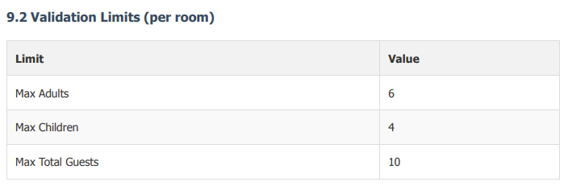

Second update: Thank you very much for your corrections!
To fully close this point, I need to conduct a test booking through your website, but it currently operates independently of the API. Could you please configure your website to use our API?

Taxes and fees - Pending test environment
In your checklist you indicated: “We take the total rate from the API (payment_types amount) and display it as the base price, then calculate and display an estimated 18% tax separately on the frontend. We do not currently parse the internal taxes array from the ETG API response.”

In this case, it is very important to indicate at least the taxes that are not included, since the client will be required to pay them upon check-in.
Taxes and fees must be excluded from the final price. ETG API sends both included and non-included taxes. Non-included taxes must be displayed to the end-user separately. To find non-included taxes, please refer to tax_data.taxes parameter and search for taxes with included_by_supplier: false data.

"tax_data": {
"taxes": [
{
"name": "city_tax",
"included_by_supplier": false, // - this tax shouldn’t be added to the total price and should be excluded and shown separately
"amount": "1130.10",
"currency_code": "HNL"
},
{
"name": "electricity_fee",
"included_by_supplier": true, // - this price is already included in the price sent in “amount”, “show_amount”
"amount": "0.02",
"currency_code": "EUR"
},

Could you please make the following adjustments:
1. Could you please add a tax section for each rate, listing all non-included taxes.
2. Each tax should be listed in the currency passed in the "currency_code" parameter.
3. It's necessary to clearly indicate to the client that non-included taxes are paid directly upon check-in.

We parse tax_data.taxes and display non-included taxes separately
Taxes with included_by_supplier: false are: - Displayed in their original currency - Shown with
"Payable at property" notice - Listed separately from room price

Second update: Thank you very much for your adjustments!
To fully close this point, I need to conduct a test booking through your website, but it currently operates independently of the API. Could you please configure your website to use our API?

Also I see that the website shows taxes in not original currency and on the search steps it shows that taxes are included:
: 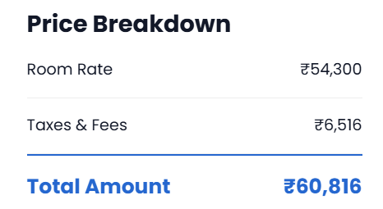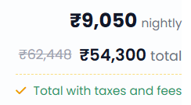
Am I right that this update was not deployed yet? If so please also update the website.

Search timeouts - Done

Cancellation policies - Pending test environment
In your checklist you indicated: “We currently do not display the cancellation deadline date or time at all. Our frontend interface shows only "Free Cancellation" or "Non-Refundable" badges based on basic flags, but does not render the specific cutoff timestamp.”

The free cancellation period includes a time limit after which a full refund will no longer be possible. Therefore, users should be fully aware of their time limit for canceling a rate.

Please parse cancellation policies from Search by methods and Retrieve hotelpage from the parameter cancellation_penalties.policies. The cancellation policies might have three layers:

 "start_at": null,
"end_at": "2025-10-21T08:59:00" // from the moment of booking until this time, the booking is refundable without penalty
"amount_charge": "0.00",
"amount_show": "0.00",
"commission_info": {
"show": {
"amount_gross": "0.00",
"amount_net": "0.00",
"amount_commission": "0.00"
},
"charge": {
"amount_gross": "0.00",
"amount_net": "0.00",
"amount_commission": "0.00"
}
}
},
{
"start_at": "2025-10-21T08:59:00" // - within this timeframe, the cancellation is possible with a partial penalty
"end_at": "2025-10-21T08:59:00",
"amount_charge": "116.80",
"amount_show": "1.60",
"commission_info": {
"show": {
"amount_gross": "2.00",
"amount_net": "1.60",
"amount_commission": "0.40"
},
"charge": {
"amount_gross": "146.00",
"amount_net": "116.80",
"amount_commission": "29.20"
}
}
},
{
"start_at": "2025-10-21T08:59:00" // - from this moment, the cancellation is possible with a full penalty
"end_at": null,
"amount_charge": "241.60",
"amount_show": "2.40",
"commission_info": {
"show": {
"amount_gross": "3.00",
"amount_net": "2.40",
"amount_commission": "0.60"
},
"charge": {
"amount_gross": "302.00",
"amount_net": "241.60",
"amount_commission": "60.40"
}
}
}
],
"free_cancellation_before":"2025-10-21T08:59:00"
},

free_cancellation_before: “2025-10-21T08:59:00” - means that end-users are allowed to cancel the booking without penalties before 2025-10-21T08:59:00. After that, full or partial cancellation penalties will apply. The rate with free_cancellation_before": null - means that there is no free cancellation. The penalties will apply immediately when the user decides to cancel.

It is important to note that we send the cancellation policies via API in the UTC+0.

May I ask you to add at least free cancellation data and time (with indication that time specified in UTC+0)?

Second update: Thank you very much for your adjustments!
To fully close this point, I need to conduct a test booking through your website, but it currently operates independently of the API. Could you please configure your website to use our API?

Citizenship / residency - Pending test environment
In your checklist you indicated: “We currently hardcode a default value (e.g., 'gb' or 'in') in the API request configuration and do not determine it from the user's IP address or provide a dropdown selection. This is verified in backend/routes/hotel_routes.py and backend/services/etg_service.py.”

This parameter is very important, as some hotels have different pricing policies for citizens of different countries. If you don't provide citizenship information during the search, a default "residency" based on the country of your contract will be applied. Therefore, if the client's citizenship differs, this could lead to potential financial losses (a room with the guest's actual citizenship may be more expensive) or a denial of registration.

We recommend collecting guest citizenship information as a first step in the search and include it in search API requests (/search/serp/geo) using the "residency" parameter.
May I ask you to make some adjustments, so that during the search phase, the client could indicate their citizenship, and ultimately it would be sent in the search requests in the "residency" parameter?

Second update: Thank you very much for your adjustments!
To fully close this point, I need to conduct a test booking through your website, but it currently operates independently of the API. Could you please configure your website to use our API?

Meal types - Pending response
In your checklist you indicated that you use the “meal” parameter to get meal types.
The "meal" field is outdated. We do not recommend using it to obtain information about dietary types, as the information may be outdated.
We pass meal types for the plan in the search API method responses in "meal_data" > "value." Also passed in "meal_data" is whether breakfast is included ("has_breakfast") and whether a child meal is not available ("no_child_meal").

Also, I'd like to describe why the meal plan distribution is important, because it is mostly about distribution of meals between adults and children.
The “no_child_meal” parameter is also included in the search responses in the “meal_data” array.
In rates where "no_child_meal": false, the meal type from "value" is included for children, while with "no_child_meal": true, it is not included.
For example:
- Search for 2 adults and 1 child, "no_child_meal": true, then the number of meals will be 2 (only for adults) because meals for children are not included.
- Search for 4 adults and 2 children, "no_child_meal": false, the number of meal plans for the rate is 6 (4 for adults and 2 for children).
- The exceptions are the breakfast-for-1 (Breakfast for one guest) and breakfast-for-2 (Breakfast for two guests), where the number of breakfasts is predetermined by the meal type name.
If this isn't taken into account, a customer might see that breakfast, lunch, and dinner are included, make a booking with their child, and after check-in discover that meal isn't included for the child. In the end this could lead to a negative customer experience.

Could you please make some adjustments by showing the “value” parameter as a meal type and adding a separate indicator of the meal's presence for children by "no_child_meal" parameter ?

After that please provide the cross-mapping list, so we can understand how each meal type is indicated on your website.

ETG meal name | Partner meal name
all-inclusive
breakfast
breakfast-buffet
continental-breakfast
dinner
Full-board
half-board
lunch
nomeal
some-meal
english-breakfast
american-breakfast
asian-breakfast
chinese-breakfast
israeli-breakfast
japanese-breakfast
scandinavian-breakfast,
scottish-breakfast
breakfast-for-1
breakfast-for-2
super-all-inclusive
soft-all-inclusive
ultra-all-inclusive
half-board-lunch
half-board-dinner

We use meal_data.value (not deprecated meal field)
Yes, we display no_child_meal warning when applicable
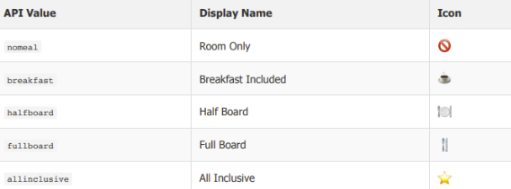
Second update: Thank you for the table provided. Could you please describe how you work with other types of meals (like, breakfast for one, breakfast for two, some meal etc.)?

Final price / Commission - Pending test environment
Here I want to clarify that you work on a net model. This means we pass you the net price for a specific rate. The commission is the markup you set on your end. You need to add this commission to the net price we pass on and then show this price to the client. Thus, you pay for the rate from your deposit, the net price of which we pass on to you in the response, and the client pays this net price plus your markup (your markup is your profit from the booking).

I also wanted to describe the parameters we use to transmit the rate price.
The "amount" parameter specifies the price in the currency set in your contract; this amount will be debited from your deposit. The "show_amount" parameter is specified in the currency you specified in the "currency" parameter in the search requests body.

Could you please clarify whether everything regarding the commission is clear, or do you have any other questions about this?

NET model - We receive net prices from ETG API - We add our markup on the frontend - Commission is calculated on our end

Second update: Thank you very much for your adjustments!
To fully close this point, I need to conduct a test booking through your website, but it currently operates independently of the API. Could you please configure your website to use our API?

Room name reflection - Pending test environment

To verify this point, I need to conduct a test booking through your website, but it currently operates independently of the API. Could you please configure your website to use our API?

room_name from /search/hp/ response
We display ETG room names as-is without modification

Second update:
To fully close this point, I need to conduct a test booking through your website, but it currently operates independently of the API. Could you please configure your website to use our API?

Early check-in / Late check-out - Done + Note
In your checklist you indicated: “We do not work with upsells for now, but we plan to integrate it at a later stage”

However I see that your website offers to provide information about early check-in and late check-out:
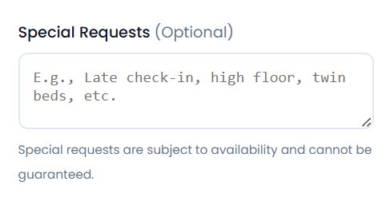
Could you please indicate whether you would like to implement this upsell option now?

Planned - Not required for launch (MVP)

Second update: Thank you! In that case, this point is closed, but when you decide to integrate it, please write to us so we can give you recommendations on how best to implement this feature.

Hotel chunk size - Done

Booking

Receiving the final booking status - Pending response
How do you receive the final booking status?
Which specific indicator from the ETG API do you rely on to determine that an order can be shown as successful to the client?

If you use the "Check booking process" method to receive the final booking status, what would the flow be if you get a "processing" status in response to the "Check booking process" request?

Second update: Am I right that you use only "Check booking process" to shows the booking status to user?
If you use another endpoints during booking confirmation, then please describe the booking confirmation in detail

Booking cut-off - Pending response
In your checklist, you specified expected and a maximum timeout of 60 seconds.
First of all, I wanted to clarify that it’s not possible to specify a dynamic timeout at the booking stage like there is for the search stage.
Our minimum timeout is 1 minute.
Our maximum timeout is 10 minutes.

May I ask you to agree on a different timeout, one that's longer than 1 minute and shorter than 10 minutes? Usually we recommend - 180 sec.

Also to avoid any misunderstandings, could you please indicate when you would like the countdown to this timeout to begin? We typically start the timeout countdown after a successful (OK, 5xx, unknown, timeout) response to "Start booking process."
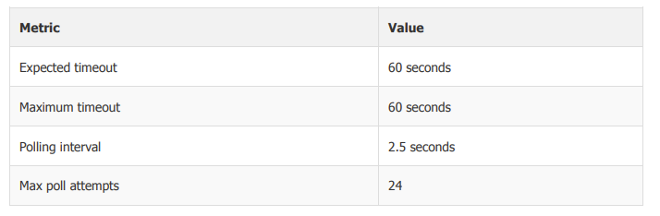

Second update: May I ask you to agree on a different timeout, one that's longer than 1 minute and shorter than 10 minutes or we should set the 60 seconds timeout on our end as you mentioned in the table above?

Errors and Status Processing Logic - Pending response
Please share the cross-mapping list of your booking statuses and the ETG API responses and the processing flow of the ETG API responses. Please provide the information as elaborated as possible.
Second update: Could you please fill these tables? It will help to better understand your statuses processing logic.
Endpoint: https://api.worldota.net/api/b2b/v3/hotel/order/booking/finish/
ETG API | Partner’s status on Frontend | The Processing Logic on Backend
Status "ok"
5xx status code
Error "timeout"
Error "unknown"
Error “booking_form_expired”
Error “rate_not_found”
Error “return_path_required”
Endpoint: https://api.worldota.net/api/b2b/v3/hotel/order/booking/finish/status/
ETG API | Your status (that you show to the end-user) | How you process it
Status "ok"
Status "processing"
Error "timeout"
Error "unknown"
5xx status code
Error "block"
Error "charge"
Error "3ds"
Error "soldout"
Error "provider"
Error "book_limit"
Error "not_allowed"
Error "booking_finish_did_not_succeed"

Confirmation e-mails - Pending adjustments
In your check list you indicated: “We do not send an email address”
I see that during your test booking in “Start booking process” call you indicated our example of email in user.email parameter:
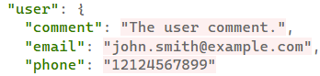
On email specified in user.email parameter our voucher with net price will be send
If you specify the client's email address, they will receive a voucher with our net price, which may raise questions about price discrepancies between the voucher and the price on your website.
Therefore, you need to specify your corporate email address as the confirmation email, then based on this generate a voucher on your end (which will include the price with your markup), and then send this voucher to the client's email.

May I ask you to make the changes described above?

We send confirmation emails using Brevo (Sendinblue) API
We do NOT send customer email to ETG API - We use our corporate email for ETG communications - We generate our own voucher with markup prices - Customer emails are sent from our system only

Second update: Thank you for adjustments!
To fully close this point, I need to conduct a test booking through your website, but it currently operates independently of the API. Could you please configure your website to use our API?

Post-Booking

Retrieve bookings - Pending adjustments

In your checklist you indicated that you use “Retrieve bookings” call to allow users to get their booking details and check if the requested modifications are in place.

Is the “Retrieve bookings” method called on the post-booking step, separately from the booking process? If not, please explain the logic.

Have you implemented a time gap between the order confirmation (via “Check booking process” or receiving booking status webhook) and the “Retrieve bookings” method? If so, please provide the time gap value configured on your side.

What will happen to the booking if the “Retrieve bookings” returns a blank response?

Yes, we use /hotel/order/info/
To allow users to: - View booking details - Download voucher - Check modification status - View cancellation terms
Yes, we implement a 2.5-second gap between status polling requests

Second update: If I understand correctly you use /order/info call after 2,5 sec from /booking/finish/status

It takes approximately 5 seconds for the current booking information to be added to /order/info. However, sometimes the information may not sync in this method even within these 5 seconds, so we generally recommend using this method within a minute gap after receiving a successful booking status via /finish/status/.
This method should not be used to confirm a booking and should only be used to create a booking history. We do not change tariff details during the booking process, so your system can use the booking detail from "Prebook rate from hotelpage step" response .Could you please indicate if it is possible to show information from the "Prebook rate from hotelpage step" method instead of information from the "Retrieve bookings" method?

